MRSA sub-group
Attendees: Pradeep, Mahesh, James, Samson, Ted

- Application of Ytex to MRSA
  - Ytex uses a relation database (SQL server)
  - Stores documents and annotations (stored in tables)
  - Sectionization allows easy addition of document sections into a custom table
  - Ytex creates tables to hold annotations
  - Ran Ytex on 10,000 documents from 200 patients
  - Ytex.mrsa_doc contains UMLS concepts
  - Ytex.mrsty contains semantics
  - Ytex.anno contains all the annotations
    - Annotations contains words, phrases, and sentances. There are various annotation types: sentances, punctuation, number…
    - All annotations has an annotation id
  - Anno_contain has nesting information
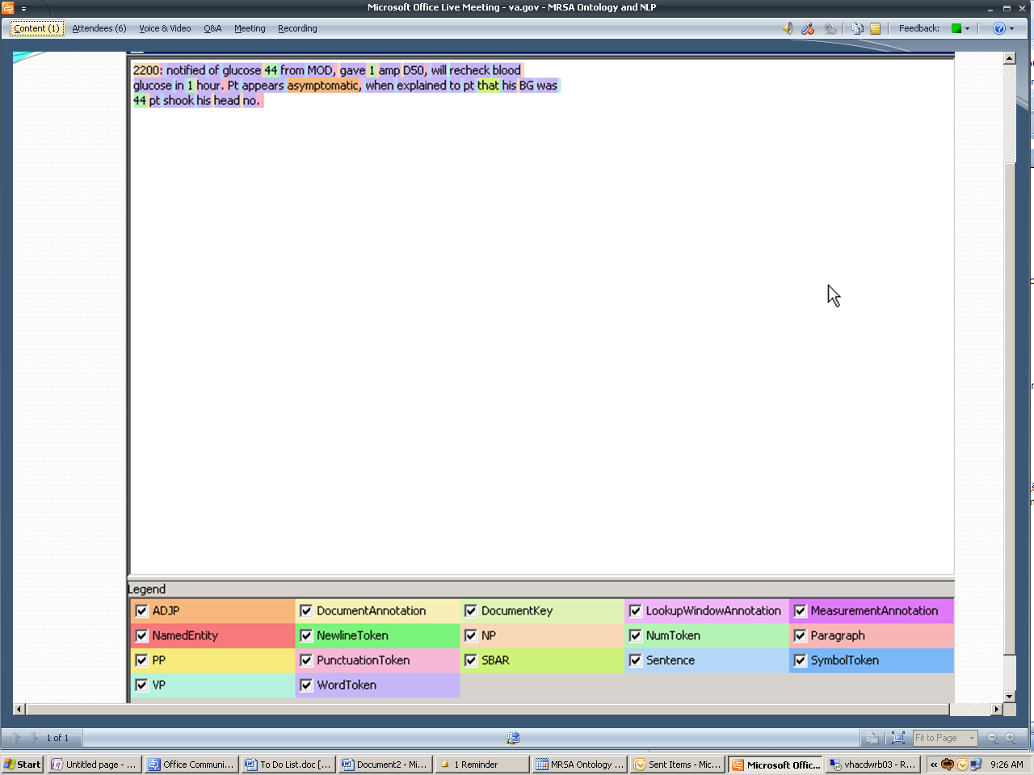
  - Each color is a different type of annotation
  - Certainty of -1 = negation
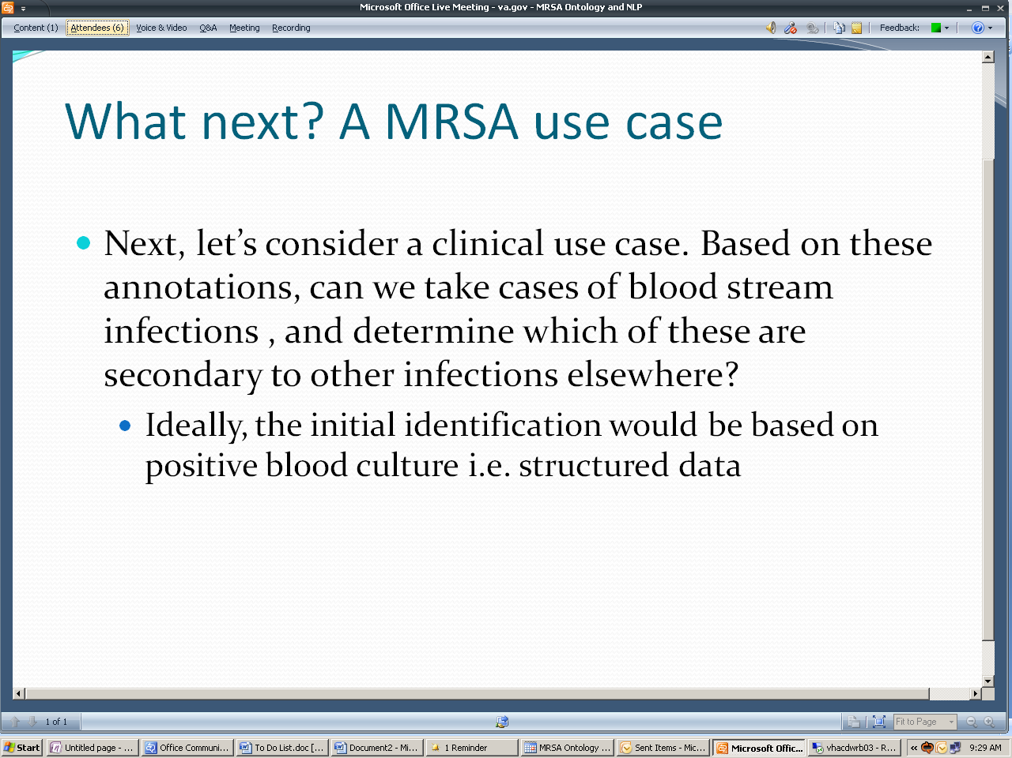
  - We will have blood culture data in the next pull (hopefully next week)
  - Primary infections are looked for to determine if the BSI is secondary. Using *itis to search for an all inclusive infections as primary infection
  - MRSA BSI document with positive blood culture are selected and date of is recorded
  - Infections are organized into groups
  - Next is finding UMLS CUI for infection terms
  - 0-14 days before the positive blood culture, patient documents are searched for infection and identify possible segments with infection terms then look at those sentances if they are relavent to primary infection
  - Source tables contain documents
  - Ytex.mrconso contains all umls concepts
    - TS = s (string), p(phrase→can be multiple words)??
    - STR = Actual string
    - Ytex runs and matches on STR
  - Ytex.v_document contains all the documents that have been run with YTEX
  - Ytex.MRSA_CUI are the infection terms found in UMLS (~4000)
  - Ytex.v_document_cui_sent shows the sentence and document from which the annotation occurs
    - Every named entity has a span and the sentence has a span, there the named entity span find the sentence within which the entity is found then pulls that sentance

